IT Infrastructure Setup for StarTech Business College

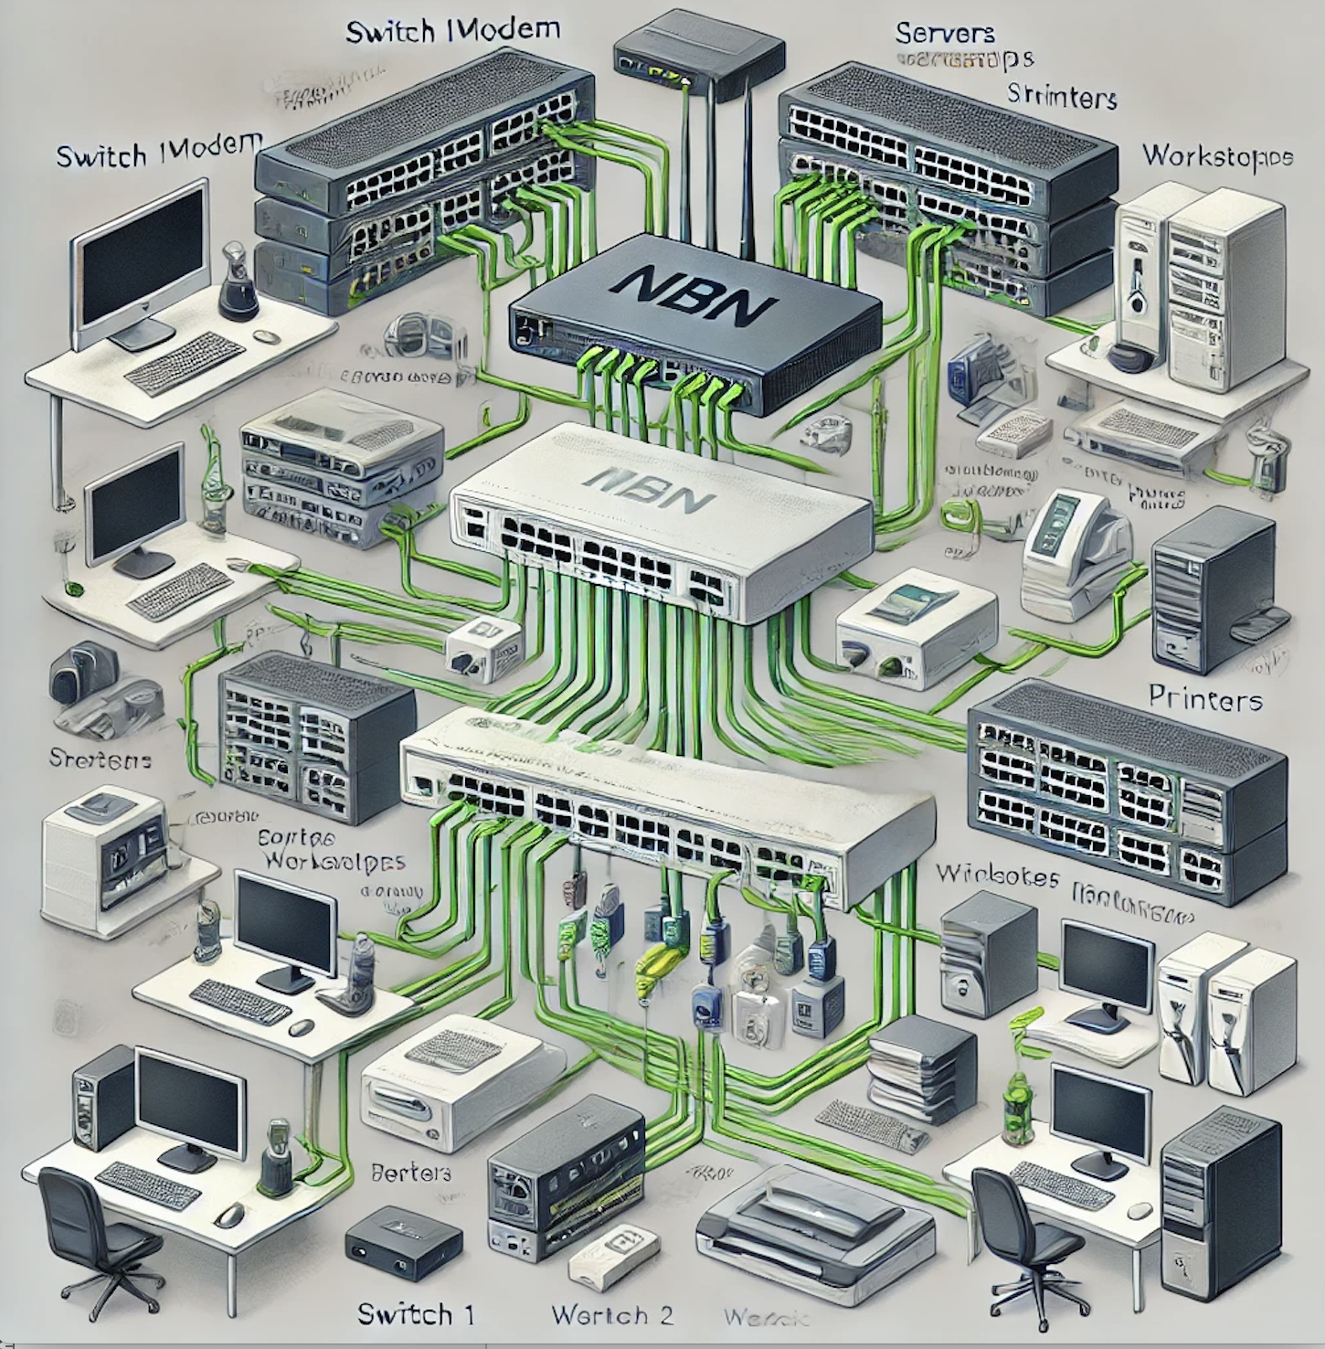

Submitted by:

Garima Rizal and Neha Pradhan

**Table of Content**

**1. Introduction 2**

**2. Network Diagram Structure:** **4**

**5. Domain Selection and Pricing Information:** **28**

**6. Server Requirement:** **29**

**7. Accuracy of Prices:** **29**

**8. Validity Period:** **29**

**9. Exclusions:** **29**

**10. Client Responsibility:** **29**

**11. Scope of Consultancy:** **29**

**12. Terms and Conditions:** **29**

**13. Product Use and Limitations:** **30**

**14. Liability and Compliance:** **31**

**15. Call to Action:** **31**

**16. Submission Deadline:** **32**

**IT Infrastructure Setup for StarTech Business College**

1. **Introduction**

This document outlines the proposed IT infrastructure for StarTech Business College, located in Sydney CBD, Australia. The goal is to set up a fully functional IT environment to support administrative, academic, and student needs. This proposal considers the requirements outlined in the project brief and aligns with Australian standards.

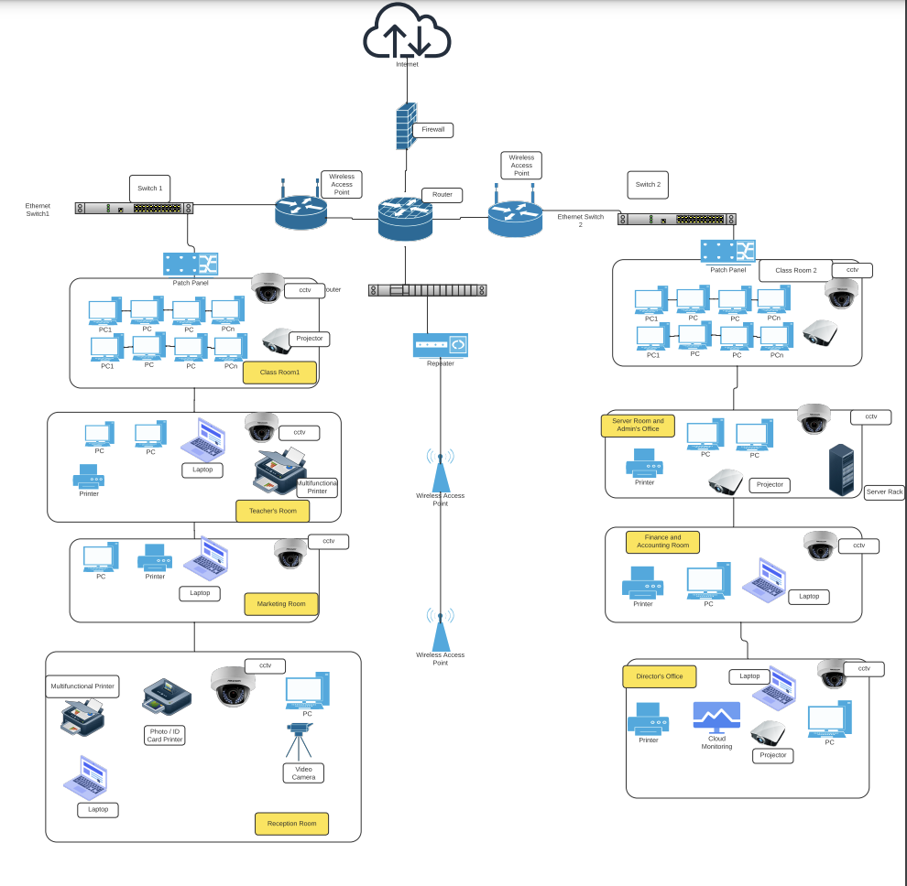

Figure 1: Network Diagram

<https://lucid.app/lucidchart/b338fab6-babd-4b45-a054-3eeef4aa6a92/edit?viewport_loc=834%2C1034%2C1774%2C799%2C0_0&invitationId=inv_d5301ba7-5107-44ab-bc1d-982497b83b52>

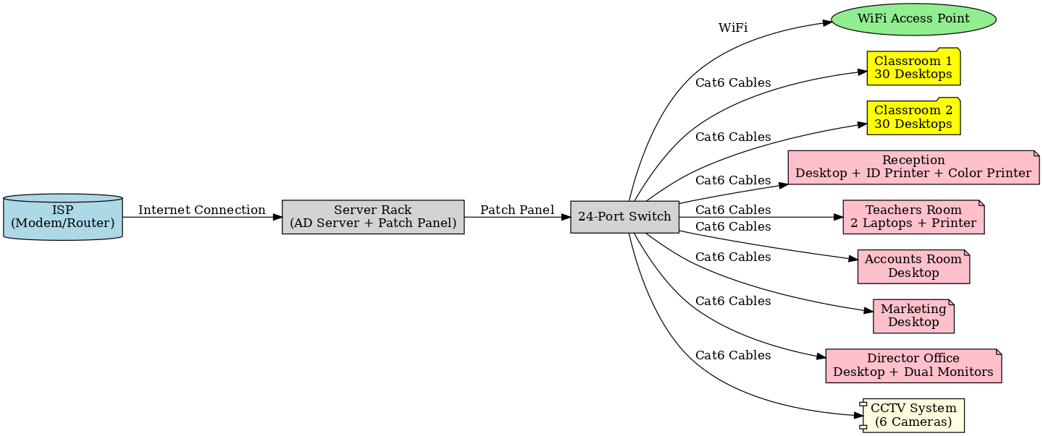

Figure 2

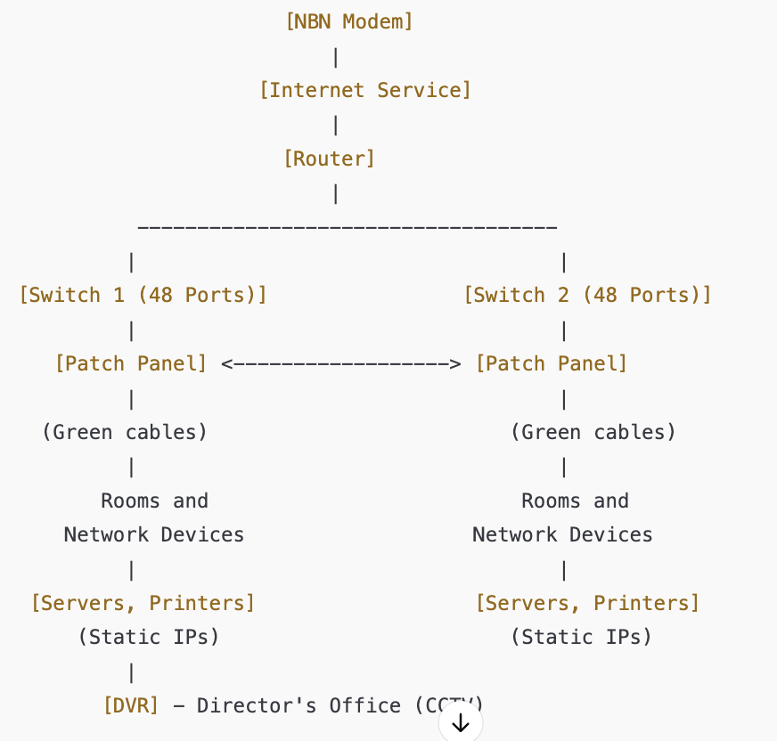

Figure 3

### **Network Diagram Structure:**

1. **NBN Modem** (provided by ISP)
   * **Connection**: The modem is connected to the router.
2. **Router**:
   * **Connection**: The router is connected to both **Switch 1** and **Switch 2**.
   * **IP Setup**: Static IP addresses are assigned to **servers** and **printers** in the network.
3. **Switch 1**:
   * **Ports**: 48-port switch connected to various devices, including servers, printers, and networked equipment.
   * **Connection**: Switch 1 is connected to the patch panel.
   * **Cabling**: Represent connections with **green cables** (indicating connections from the patch panel).
4. **Switch 2**:
   * **Ports**: 48-port switch similarly connected to other devices, including additional printers, workstations, and possibly other networked equipment.
   * **Connection**: Switch 2 connects to both the patch panel and other rooms for network distribution.
   * **Cabling**: Represent connections from Switch 2 with **black cables** (indicating direct connections from the switch to network devices).
5. **Patch Panel**:
   * **Role**: Distributes network connections to various rooms. The patch panel is the central hub where wiring from the switches and other network devices converge and branch out.
   * **Cabling**: **Green cables** represent connections coming from the patch panel to various rooms and devices.
6. **DVR (Director's Office)**:
   * **Role**: The DVR records footage from CCTV cameras located throughout the network.
   * **Connection**: The DVR connects to the network via either Switch 1 or Switch 2, depending on your setup.
7. **Access Points**:
   * **Role**: These are wireless access points providing Wi-Fi access to users across the network.
   * **Connection**: The access points connect to Switch 1 and/or Switch 2 to provide network access wirelessly.
8. **Black-and-White Printers**:
   * **Placement**: Each department has a black-and-white printer connected to the network, assigned private static IPs

**3. Detailed Cost Estimate**

The following table outlines the detailed cost estimate for the hardware, software, and labor required to set up the IT infrastructure for StarTech Business College.

| Items Required | Quantity | Provider/Supplier/Brand/Model | Description | Cost (AUD) | Purchase Link |
| --- | --- | --- | --- | --- | --- |
| Internet | 1 | Telstra Business | High-speed business internet connection (500 Mbps) | $200/month | <https://www.telstra.com.au> |
| Server Hardware | 1 | Dell | Dell PowerEdge T40 Server | $1500 | <https://www.dell.com.au> |
| Wi-Fi | 1 | Netgear | Netgear Nighthawk AX12 Router | $500 | <https://www.netgear.com> |
| Router | 1 | Cisco | Cisco RV340 Dual WAN Router | $350 | <https://www.cisco.com> |
| Ubiquiti UniFi U6 Lite Wireless Access Point | 1 | Ubiquiti | * [Specifications](https://www.scorptec.com.au/product/networking/access-points-&-extenders/104635-u6plus?gad_source=1&gclid=CjwKCAiAgoq7BhBxEiwAVcW0LMF6QiLwdkuVBeavsU3MOI6CdrO-WvCMLBGfxG-qXeEps8HHCTPsRBoCH84QAvD_BwE) | $199 | <https://www.scorptec.com.au/cart> |
| TP-Link48-port switch | 2 | TP-Link | * [Specifications](https://www.jw.com.au/product/tp-link-sg3452-jetstream-48-port-gigabit-layer-2-managed-switch-with-4-sfp-slots?gad_source=1&gclid=CjwKCAiAgoq7BhBxEiwAVcW0LCoqvMQmgK6QnwERn6VQjjwJPRIqX3rG0FHV25eZTGRywPeA2RNIgxoCGu0QAvD_BwE) | $551.08 | <https://www.jw.com.au/checkout/#shipping> |
| Wall Mount Server Rack | 2 | 4cabling | * [Specifications](https://www.4cabling.com.au/4cabling-12ru-w600mm-x-d450mm-wall-mount-server-rack.html?utm_source=google_shopping&gad_source=1&gclid=CjwKCAiAgoq7BhBxEiwAVcW0LKyFgqfvlSjjgMGKUkzXxinFNDv1RHqTT22B30haLk-VA2xojQ1LCRoCVK4QAvD_BwE) | $493.98 | <https://www.4cabling.com.au/checkout/cart/> |
| Wall Mount Patch Panel | 1 | 4cabling | * [Specifications](https://www.4cabling.com.au/4cabling-12-port-cat-6-wall-mount-patch-panel.html) | $75.24 | <https://www.4cabling.com.au/checkout/cart/> |
| CAT6 Ethernet Cable Reel Box | 1 | 4cabling | * [Specifications](https://www.4cabling.com.au/cat6-ethernet-305m-cable-reel-box-utp-lan-cable-with-solid-conductor-green.html) | $231 | <https://www.4cabling.com.au/cat6-ethernet-305m-cable-reel-box-utp-lan-cable-with-solid-conductor-green.html> |
| Epson EB-FH06 1080p 3LCD Projector white | 4 | Epson | * [Specifications](https://jw.com.au/product/epson-eb-fh52-data-projector-portable-4000-ansi-lumens-3lcd-1080p-1920x1080-black-white?gad_source=1&gclid=CjwKCAiAgoq7BhBxEiwAVcW0LB3JDt2V9T4xMyasv7OM5GJiYNKqH88J1W-n-L90GGty5v6mAH4wfxoC6AEQAvD_BwE) | $1087 | [Purchase link](https://jw.com.au/product/epson-eb-fh52-data-projector-portable-4000-ansi-lumens-3lcd-1080p-1920x1080-black-white?gad_source=1&gclid=CjwKCAiAgoq7BhBxEiwAVcW0LB3JDt2V9T4xMyasv7OM5GJiYNKqH88J1W-n-L90GGty5v6mAH4wfxoC6AEQAvD_BwE) |
| Atdec Telehook Projector Ceiling Flush Mount | 4 | Projector Guys | * [Specifications](https://www.projectorsaustralia.com.au/atdec-telehook-projector-ceiling-flush-mount?gad_source=1&gclid=CjwKCAiAgoq7BhBxEiwAVcW0LHuvbTQdJqGqwiDgCcrQYiFJMWXhzqaocIyg9phnulLgqM7w-Oda2hoCPVUQAvD_BwE) | $157 | [Purchase Link](https://www.projectorsaustralia.com.au/atdec-telehook-projector-ceiling-flush-mount?gad_source=1&gclid=CjwKCAiAgoq7BhBxEiwAVcW0LHuvbTQdJqGqwiDgCcrQYiFJMWXhzqaocIyg9phnulLgqM7w-Oda2hoCPVUQAvD_BwE) |
| Domain | 1 | GoDaddy | Domain:Startech.educ.au | $83.60/year | <https://www.godaddy.com/en-au/domainsearch/find?domainToCheck=Startech.education> |
| Printers | 1 | HP | HP LaserJet Pro MFP M428fdw | $600 | <https://www.hp.com> |
| Brother MFC-L8690CDW Colour Laser Multifunction Printer | 1 | Brother | * [Specifications](https://www.officeworks.com.au/shop/officeworks/p/brother-mfc-l8690cdw-colour-laser-multi-function-printer-brmfcl8690?istCompanyId=0403b0ba-0671-498f-aeb7-e2ff71b61924&istFeedId=00ff5695-1f12-4ff3-82f4-49dd39a43a69&istItemId=wliawmpqq&istBid=t&gad_source=1&gclid=CjwKCAiAgoq7BhBxEiwAVcW0LK7BDWRZuSw8sGA6ikzpCEQRTzq6m14mNmEx_pCeSlmKDcJfZ5KmuRoCLy8QAvD_BwE&gclsrc=aw.ds) | $747 | <https://www.officeworks.com.au/app/checkout/> |
| Badgy 100 Plastic Card Printer | 1 | Badgy | * [Specifications](https://www.officeworks.com.au/shop/officeworks/p/badgy-100-plastic-card-printer-badgy100p?region_id=GTYP2H&gad_source=1&gclid=CjwKCAiAgoq7BhBxEiwAVcW0LD3z-S-am4uFbAVwLFXhW8Pyf_Bw-gqesODfjCXfeaNW1ARvpubYvBoCSFQQAvD_BwE&gclsrc=aw.ds&regionIdSet=true) | $999 | <https://www.officeworks.com.au/app/checkout/> |
| Phones | 3 | Poly | Polycom VVX 411 Business Media Phone | $250 | <https://www.poly.com> |
| Desktops | 30 | Lenovo | Lenovo ThinkCentre M720q | $15000 | <https://www.lenovo.com> |
| Laptops | 7 | Dell | Dell Latitude 5520 | $4000 | <https://www.dell.com.au> |
|  |  |  |  |  |  |
| Additional Monitors | 5 | Samsung | Samsung 24-inch LED Monitor | $1000 | <https://www.samsung.com> |
| Projector | 2 | Epson | Epson EB-2250U Business Projector | $1500 | <https://www.epson.com.au> |
| CCTV System | 1 | Arlo | Arlo Pro 4 Spotlight Camera System (6 cameras) | $1800 | <https://www.arlo.com> |
| Server Rack | 1 | APC | APC NetShelter SX 42U Server Rack | $2000 | <https://www.apc.com> |
| Antivirus Software | 30 | McAfee | McAfee Endpoint Security for Business | $500/year | <https://www.mcafee.com> |
| Microsoft 365 Business Premium | 30 | Microsoft | Cloud-based productivity suite | $3000/year | <https://www.microsoft.com> |
| Video Conferencing System | 1 | Logitech | Logitech Rally Plus Video Conferencing System | $2500 | <https://www.logitech.com> |
| Videology Full HD FLASH-SYNC Webcam for facial Photo IDs with Flash and 12mm Lens | 1 | Videology | * [Specification](https://www.bhphotovideo.com/c/product/1637417-REG/videology_24c708af_1_full_hd_usb_2_0.html?gad_source=1&gclid=CjwKCAiAgoq7BhBxEiwAVcW0LNXrHwC4UZRbOfYuTixs1hB2Rl8p86ptOq437Xer37wWcNu4UrM_LhoCrnIQAvD_BwE) | $871.94 | <https://www.bhphotovideo.com/a/cart> |
| Labor Costs | 50 hours | Local IT Services | Installation, configuration, and testing | $4000 | N/A |
| Total One-Time Cost |  |  |  | $35000.00 | N/A |
| Total Recurring Cost (Annualized) |  |  |  | $3700.00 | N/A |
| Consultation Fee | 1 | N/A | Professional IT consultation services | $5000 | N/A |
| Total |  |  |  | $816,472.90 Approx |  |

**4. Necessary steps for Creating OU and To set up the entire system**

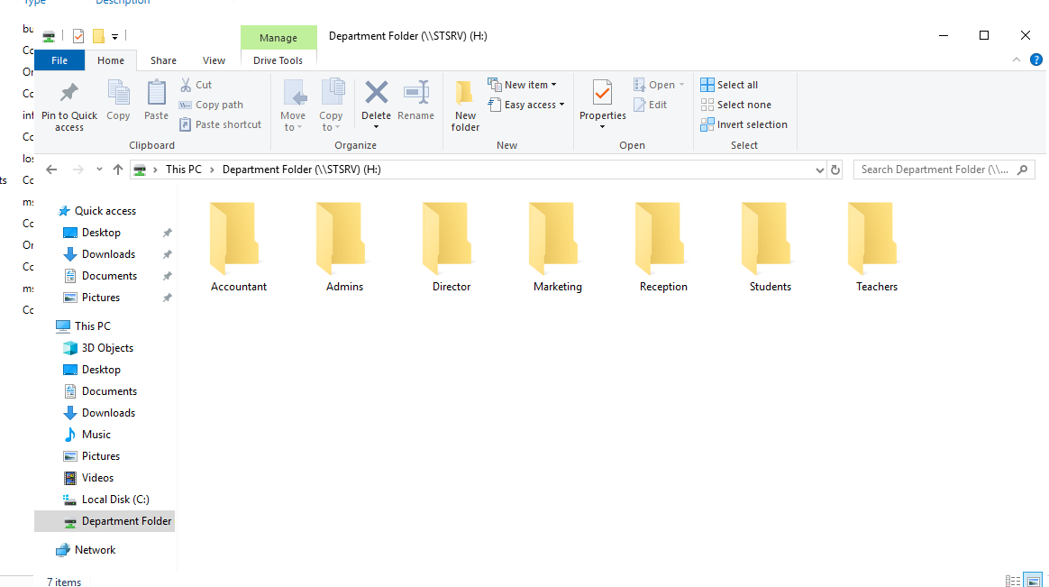

Creating Dedicated folder pic 1

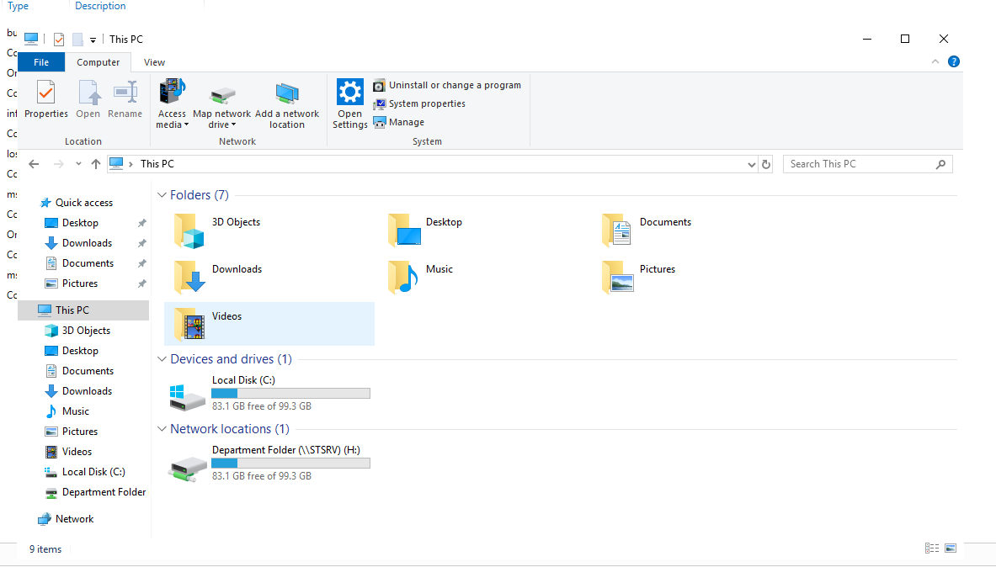

Ratan Khan Share Department folder (Pic2)

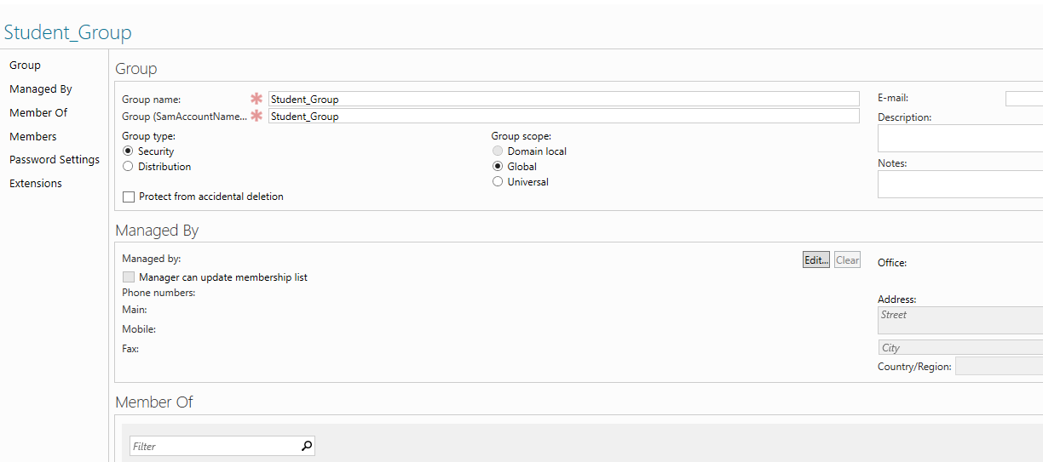

Creating Student Security Group (pic3)

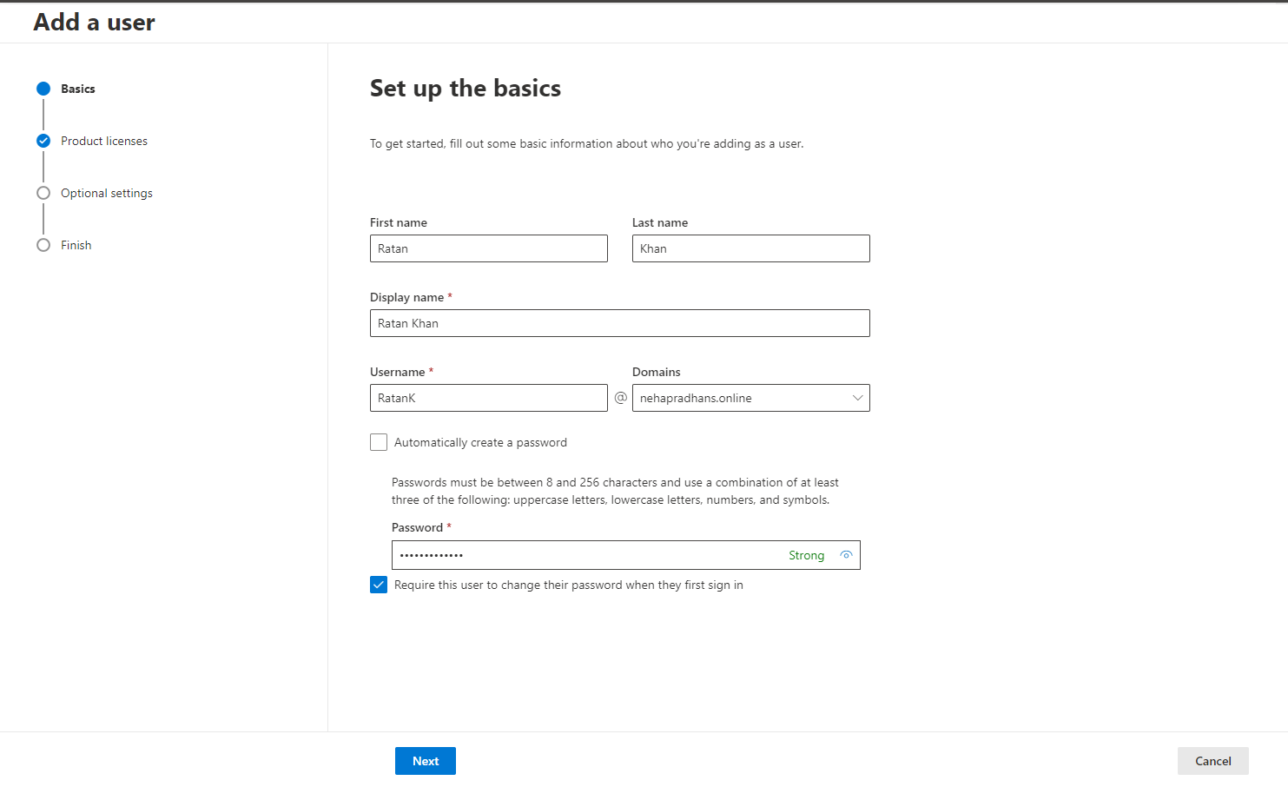

Setting up Microsoft 365 for Director Ratan Khan(pic4)

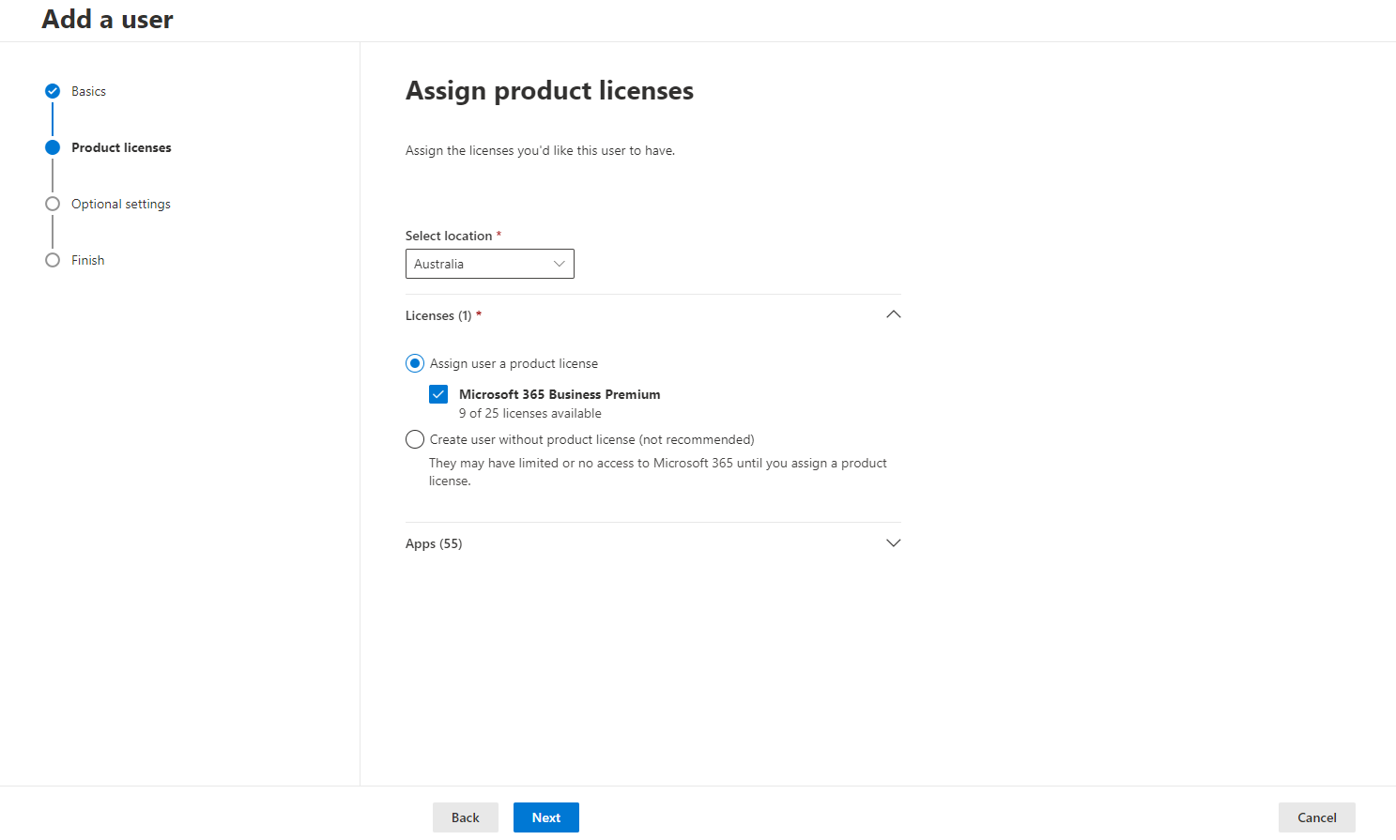

Microsoft License 365 for Ratan Khan(pic 5)

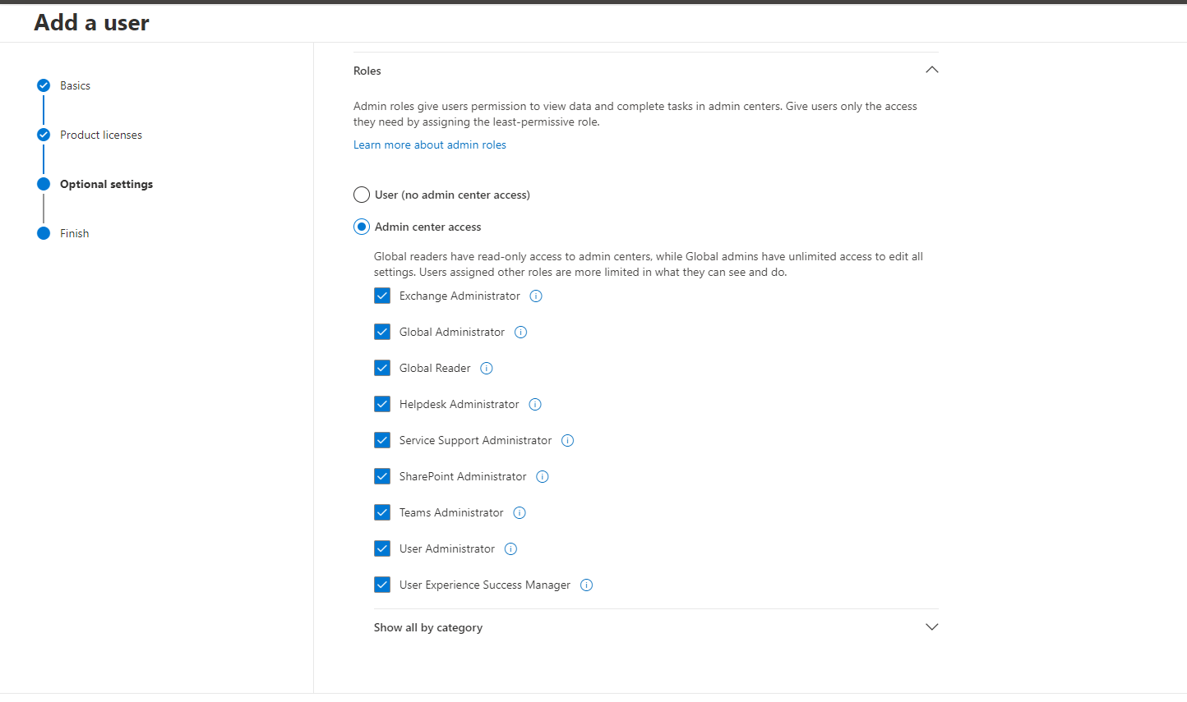

Admin Access Provided to Ratan Khan (pic6)

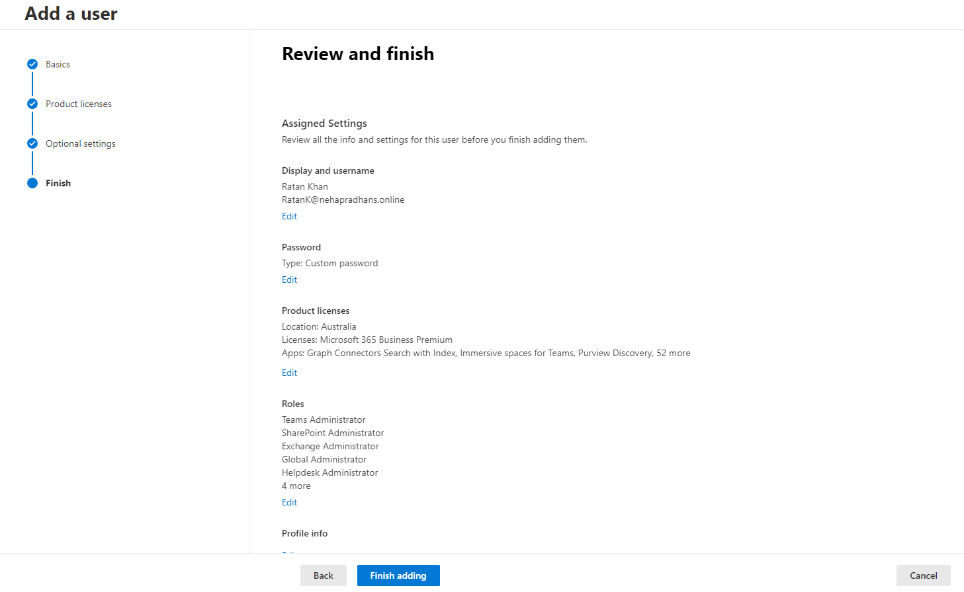

Finalizing Admin Access to Ratan Khan(pic 7)

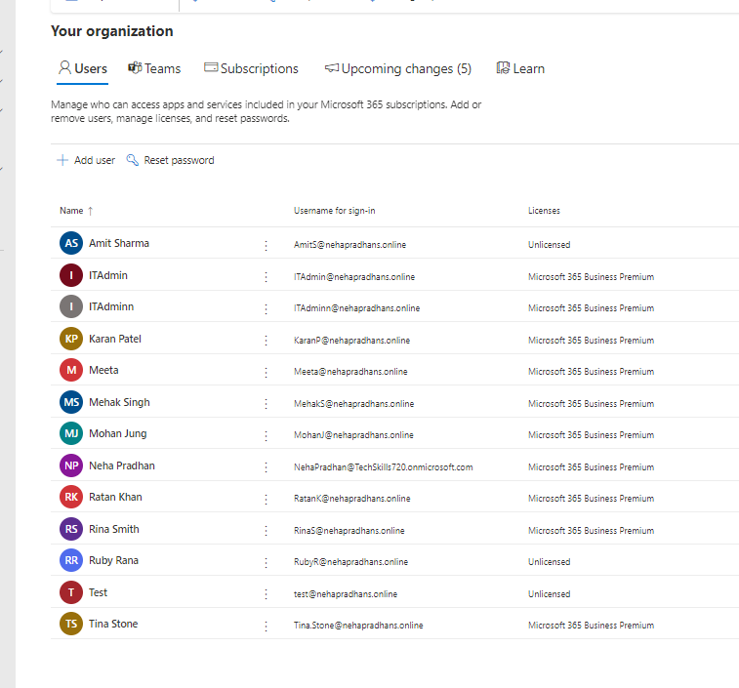Multiple User in Microsoft 365 Access (Pic7)

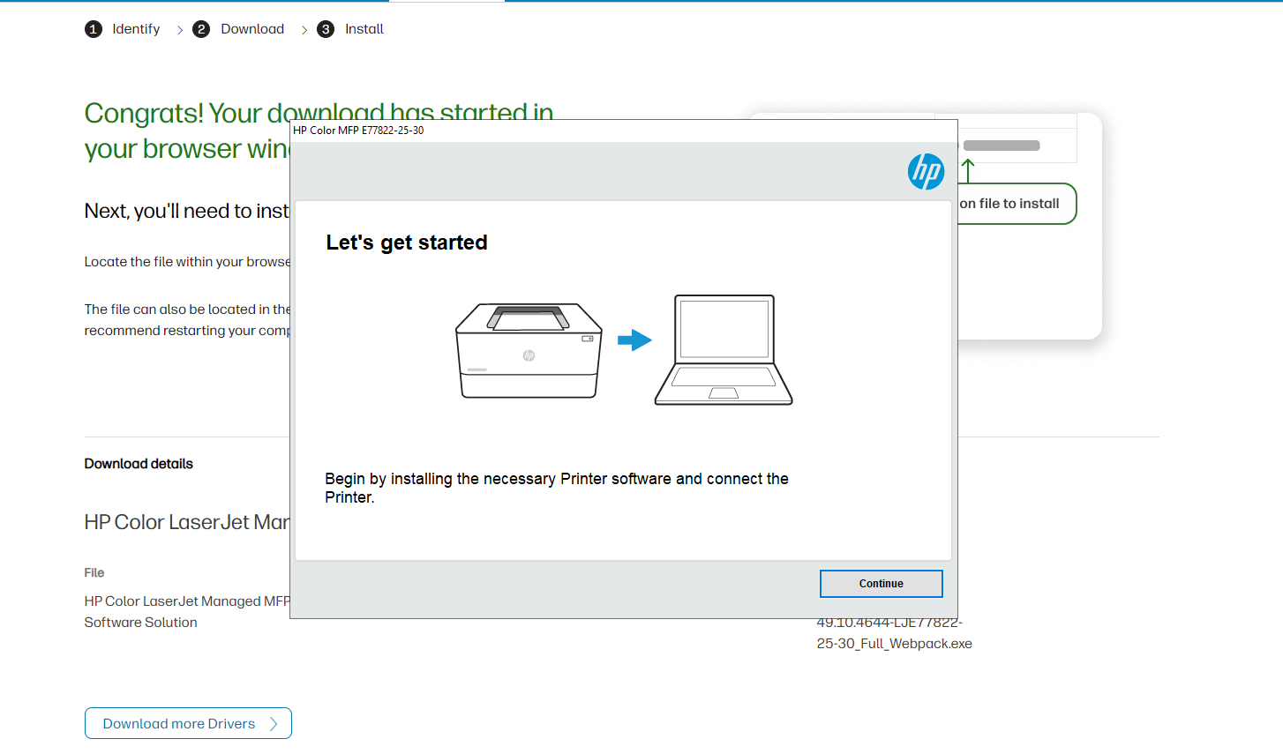

Printer

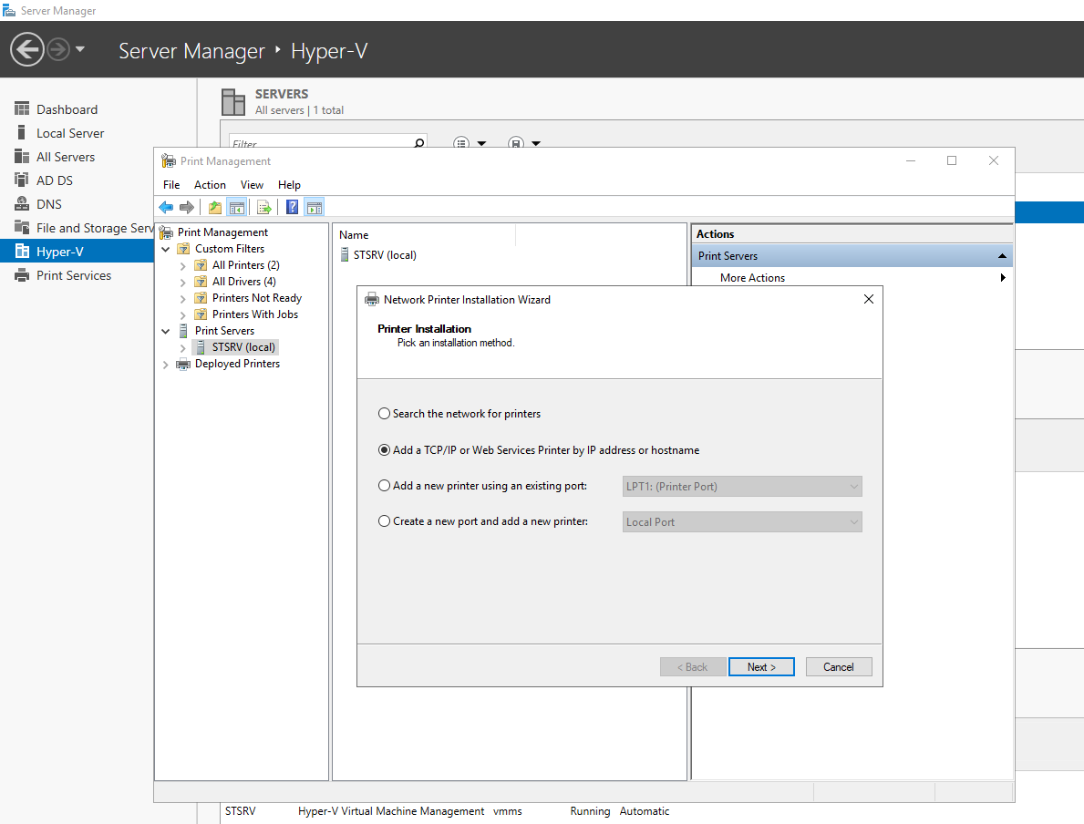

Adding printer Configuration for the network setup (pic8)

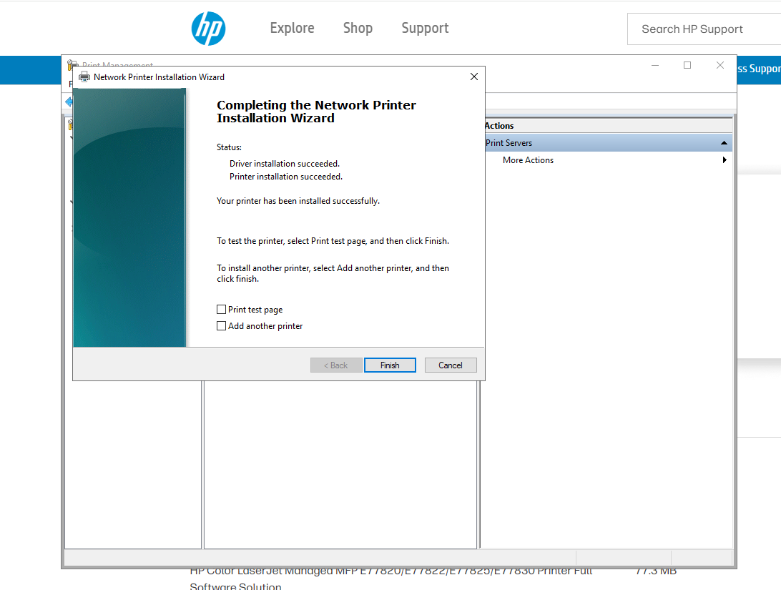

Printer Deployment Config (pic 9)

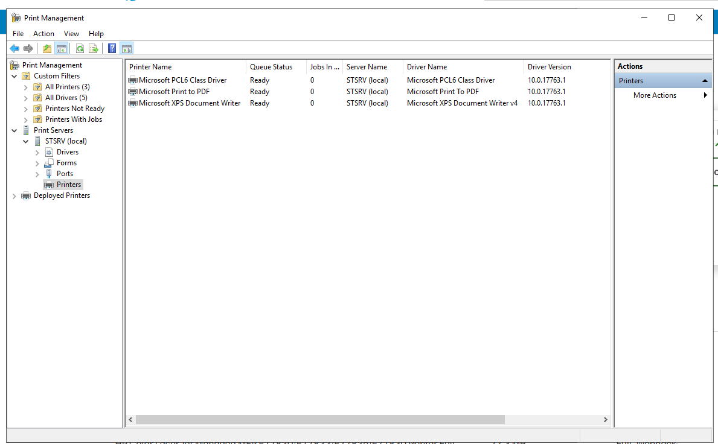

Printer Names (Pic10)

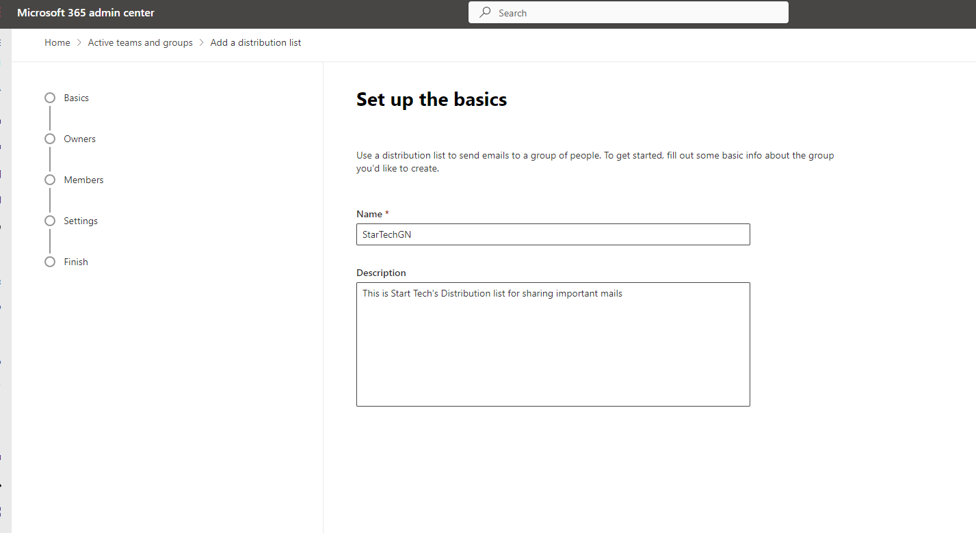

Distribution List (pic11)

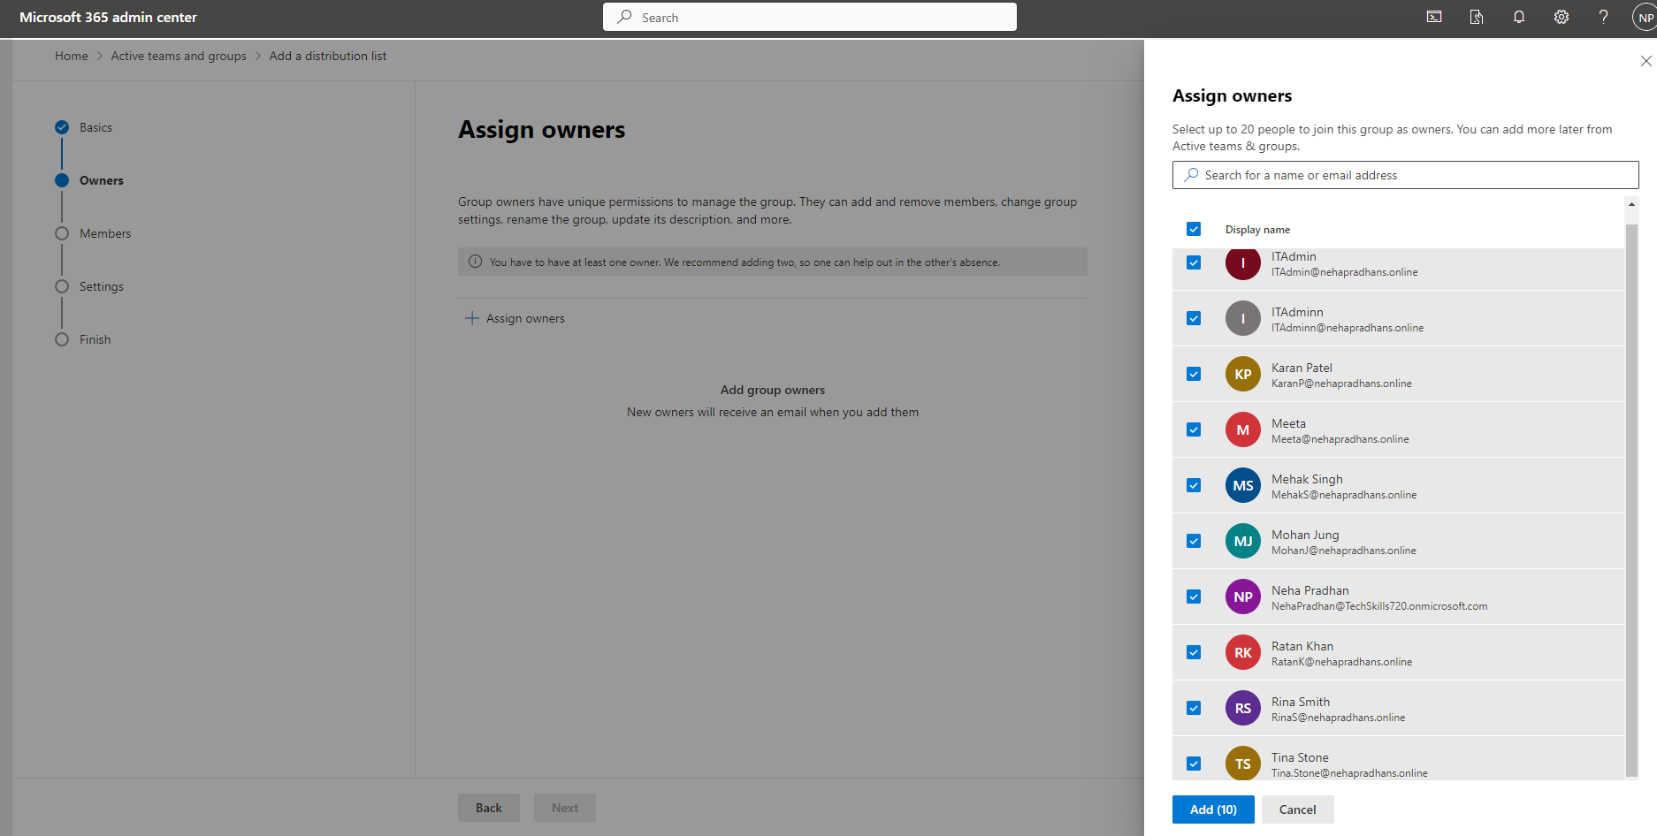

Distribution List (pic12)

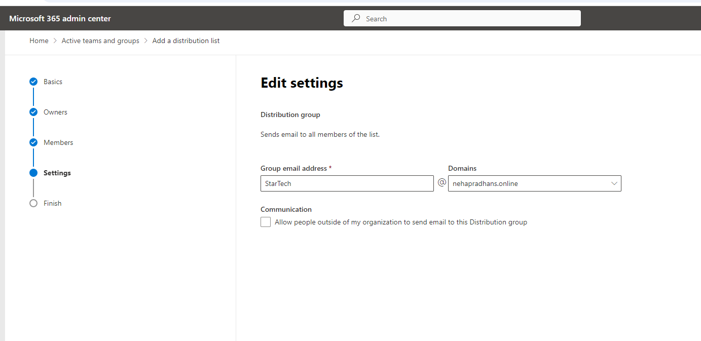

Distribution List(pic 13)

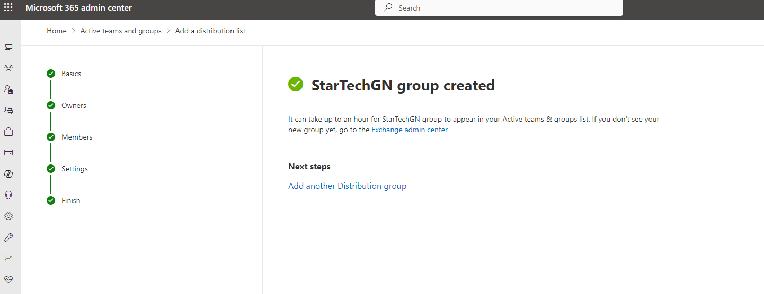

Distribution List (Pic 14)

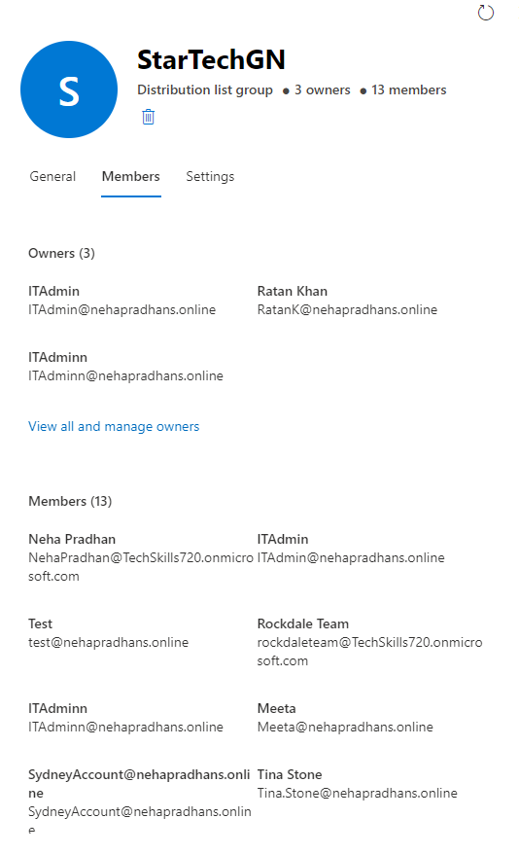

Distribution List Owners and Members(pic 14)

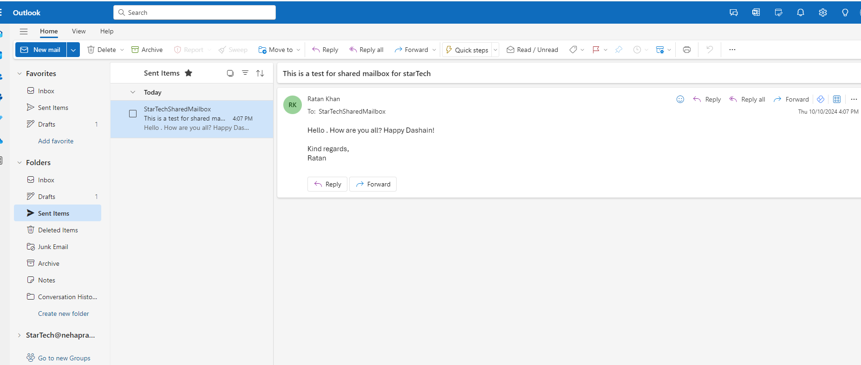

Testing a shared mailbox

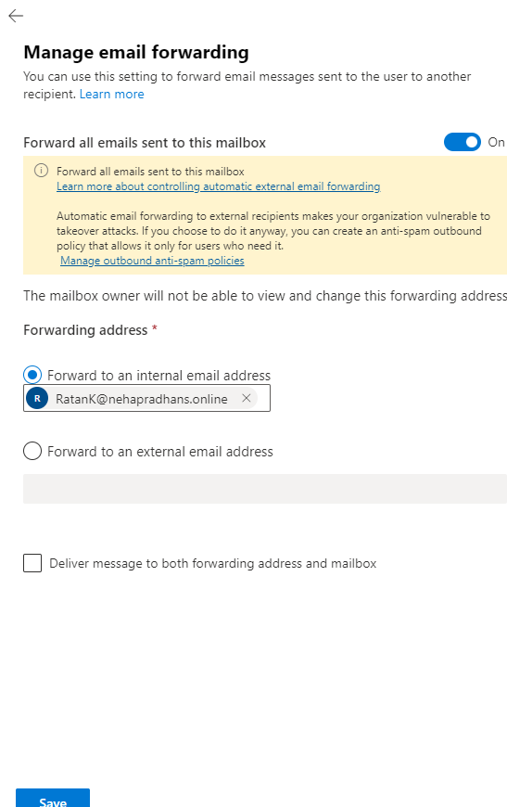

Email forwarding to Ratan Khan

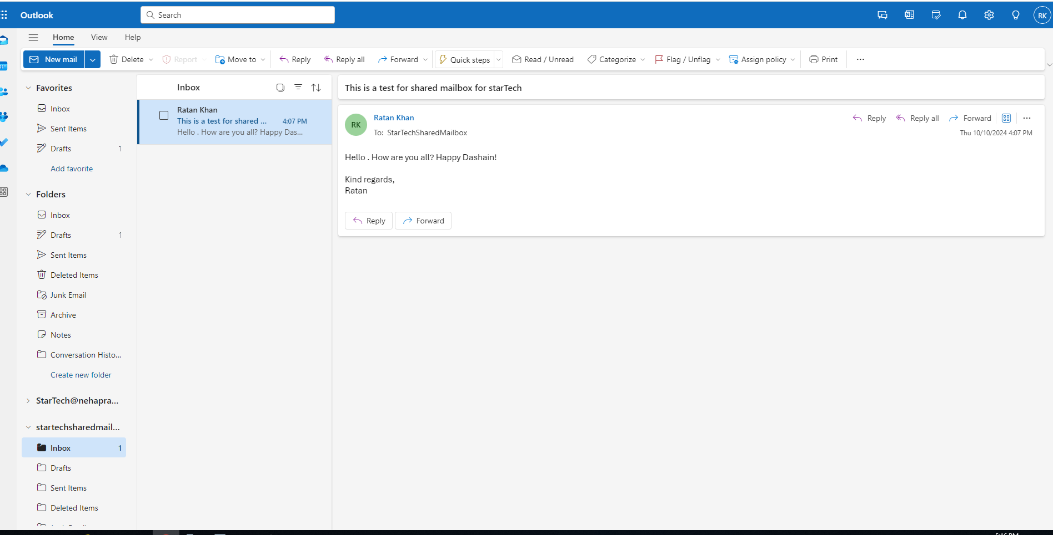

Ratan Khan receiving email from Shared mailbox

(pic 16)

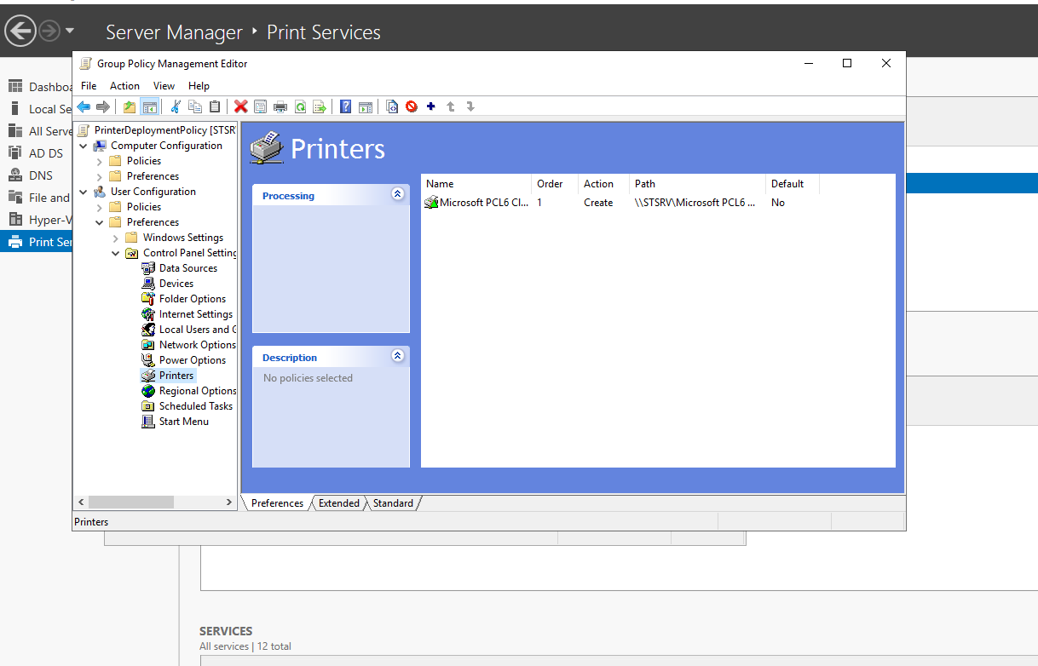

Printer Deployment (Pic16)

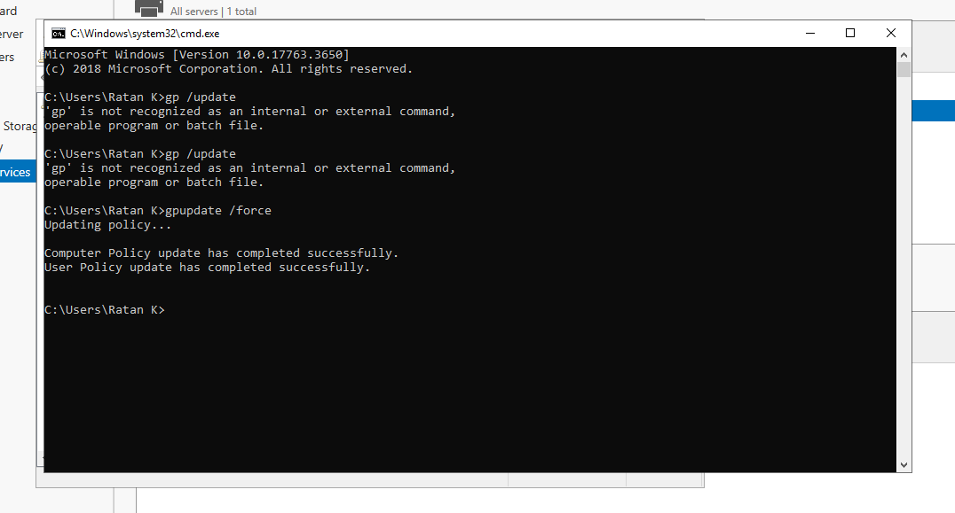

Group Policy Printer Deployment

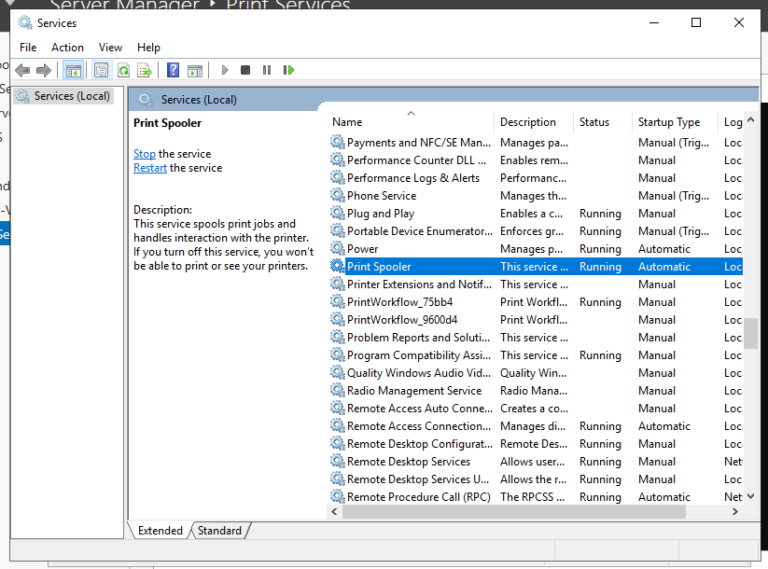

Print Spooler(pic17)

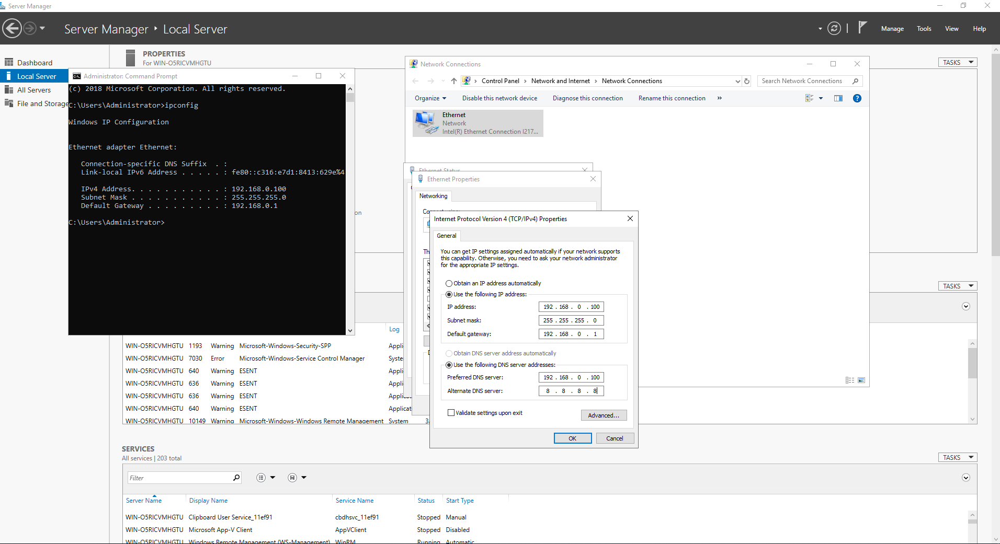

Ethernet Configuration(Pic18)

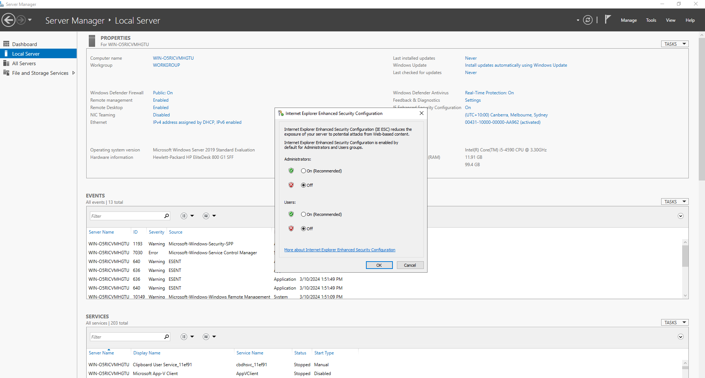

Firewall config (Pic 19)

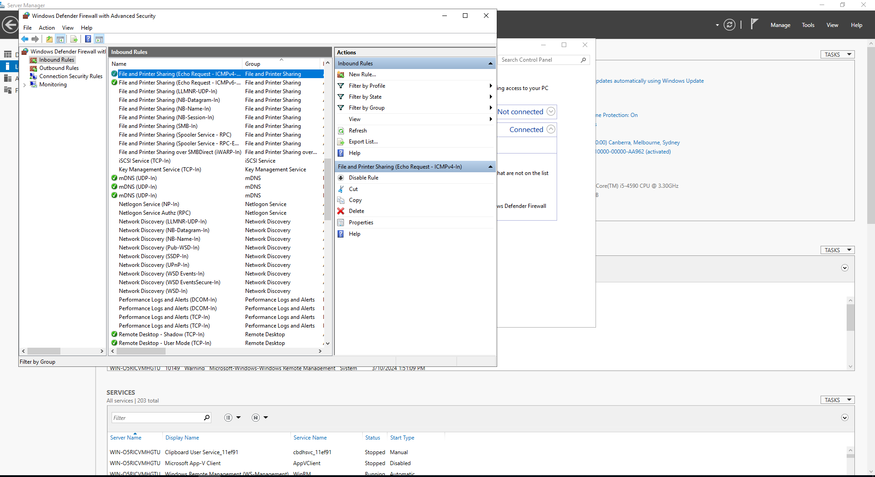

Firewall Defender Config(pic20)

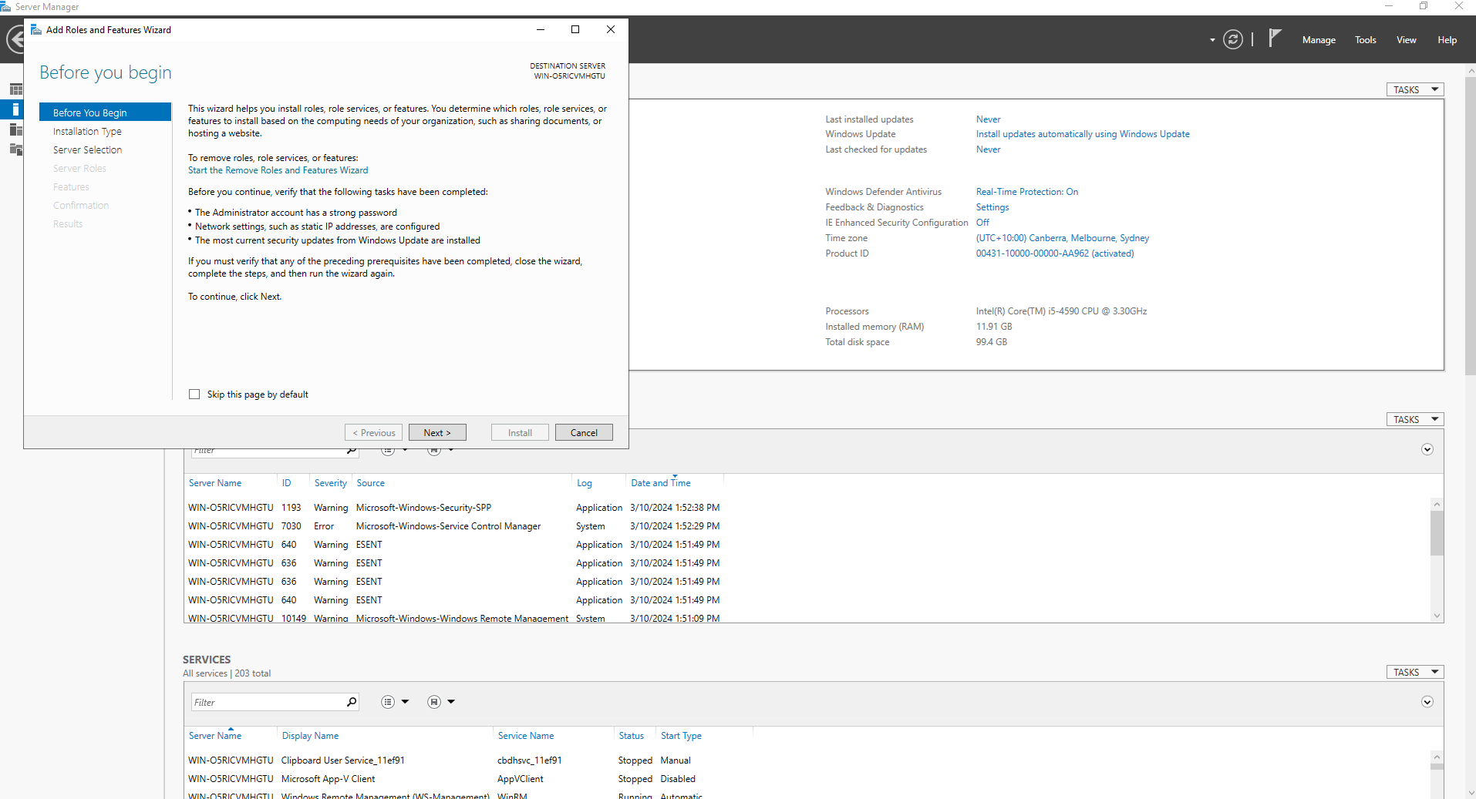

Adding Roles and Features(pic21)

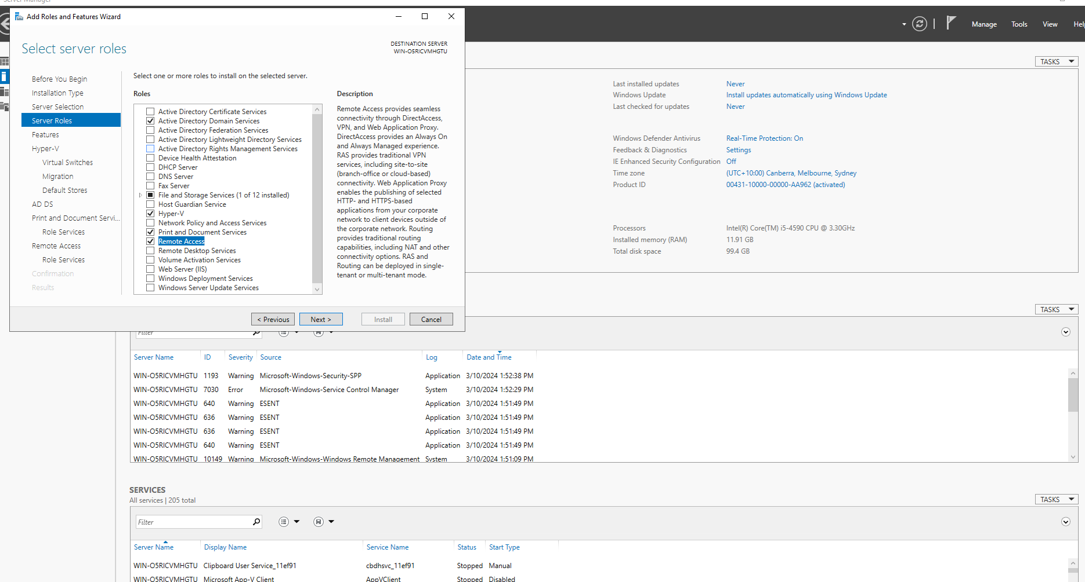

AD HyperV Printer Installation(pic22)

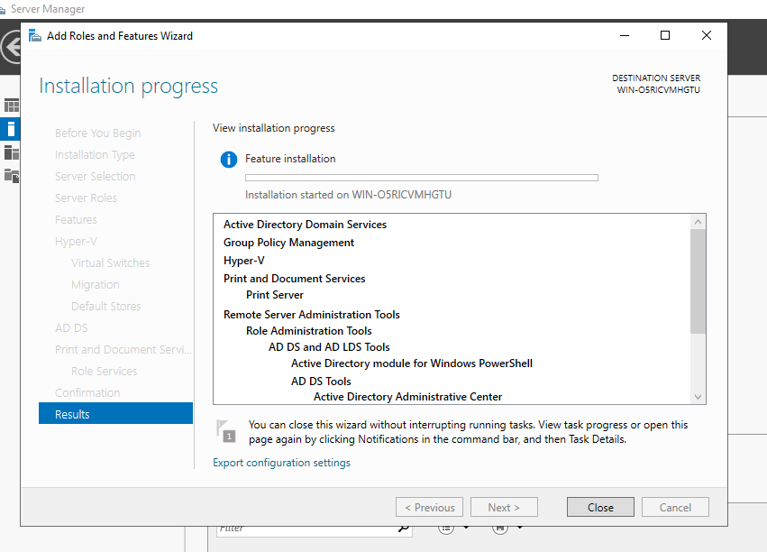

Installation AND PrintHyper V(pic23)

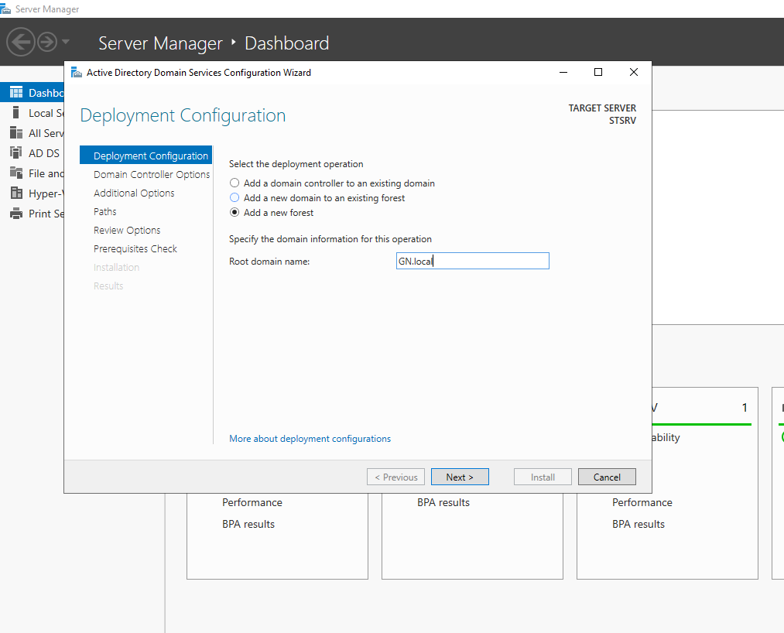

Domain Controller Configuration(Pic24)

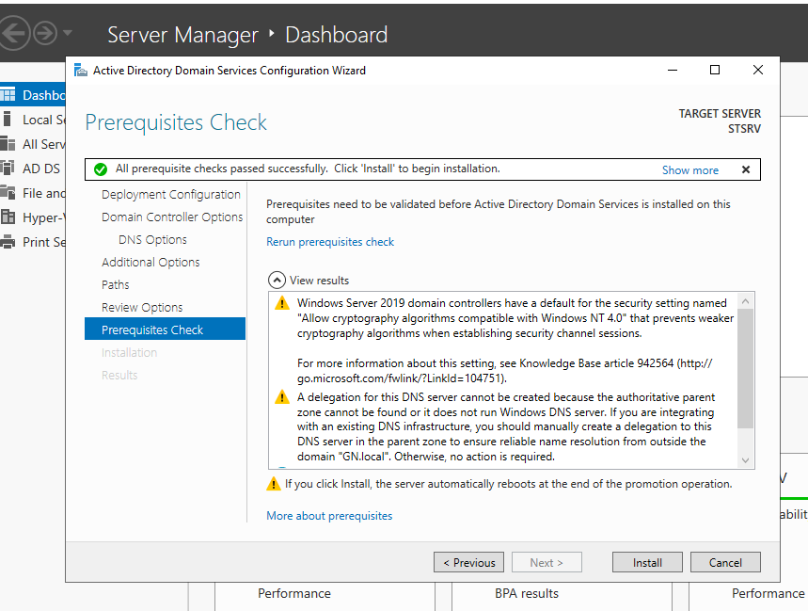

Domain Controller Prerequisites (pic 25)

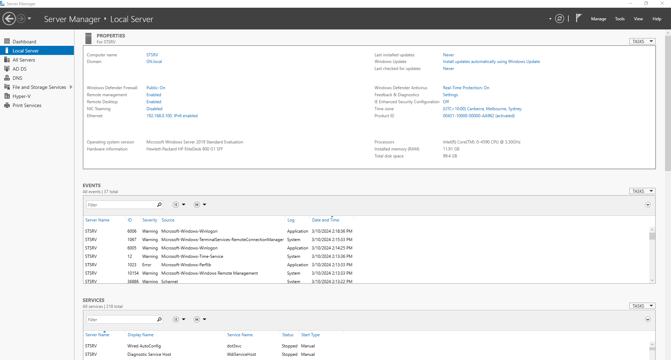

Post Config Screen (Pic 26)

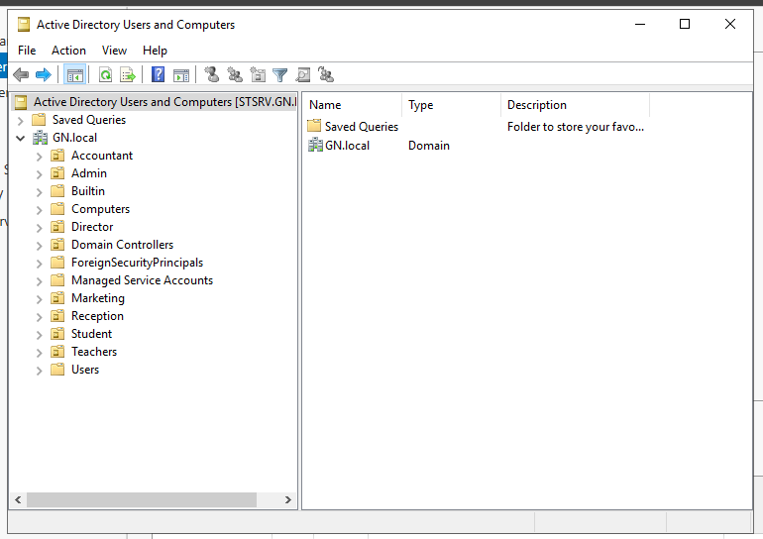

Active Directory Creating OU(pic27)

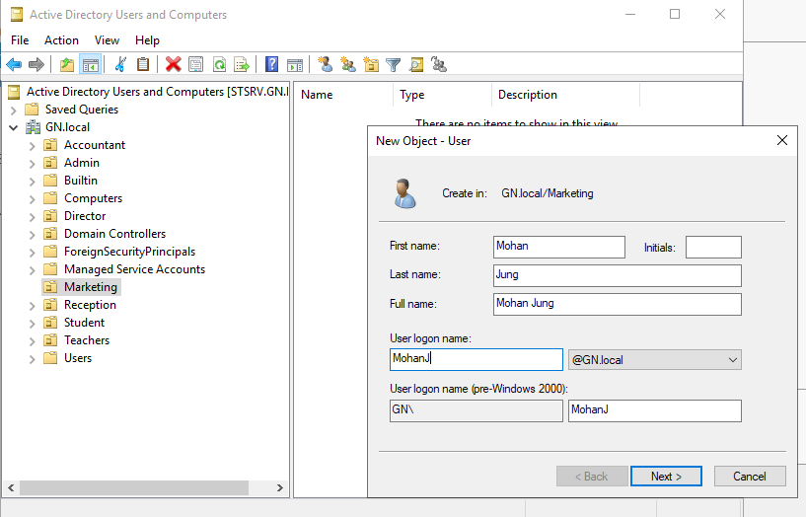CreatingUsers(pic28)

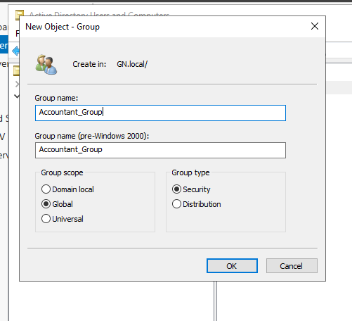

Creating Security Group (pic29)

### **5. Domain Selection and Pricing Information:**

Several domain options are available, but given that this is an educational institution, a domain name with extensions such as .edu or .education would be more appropriate. An example of a relevant domain, priced at $83.60 per year, is provided above.



### **6. Server Requirement:**

As per the project requirements, it is necessary to have a dedicated server for the business. The following steps outline the process for acquiring and implementing the server.

### **7. Accuracy of Prices:**

* The prices listed in this document are accurate as of the date of publication, based on the most current market research and vendor pricing available at that time.
* Prices are subject to change due to market conditions, currency fluctuations, updates from vendors, promotional offers (e.g., sales or clearance discounts), or other external factors.

### **8. Validity Period:**

* This pricing estimate is valid for a period of 4 weeks from the date of this document. After this period, prices may change. It is advisable to check for the most current pricing before making a purchase.

### **9. Exclusions:**

* The pricing provided does not include unforeseen costs such as taxes, shipping fees, installation charges, or additional configuration expenses that may arise during the procurement or implementation process.

### **10. Client Responsibility:**

* Clients are encouraged to verify prices with vendors at the time of purchase to ensure the most accurate and up-to-date information.

### **11. Scope of Consultancy:**

* This document is a consultancy deliverable and should not be considered a binding quotation or purchase agreement. It offers recommendations based on the client’s stated requirements.

### **12. Terms and Conditions:**

1. **Consultation Purpose:**
   * This document is intended to provide informed recommendations based on the client’s stated needs. It does not guarantee performance, suitability, or adaptability for specific purposes.
2. **Implementation Response:**
   * Upon receiving client approval, the implementation phase will commence immediately. The client will receive a detailed project plan, including timelines for key milestones and deliverables. Regular updates will be provided to ensure the project is progressing according to plan.
   * Any delays, scope changes, or issues encountered during the implementation will be communicated promptly. We will work closely with the client to address and resolve any challenges that may arise.
   * The implementation response is designed to ensure the project meets the client’s needs and is completed in a timely, efficient manner.
3. **Service Level Agreement (SLA):**
   * **Scope of Service:** This SLA outlines the expected level of service that will be provided during the project’s implementation phase. It includes the timeline for delivery, maintenance, and support.
   * **Response Time:** The consultant commits to providing a response to any service-related inquiries within 24 hours during business hours (Monday to Friday, 9:00 AM to 5:00 PM).
   * **Uptime Guarantee:** For hosted services, an uptime of 99.9% is guaranteed, excluding planned maintenance periods. In the event of service downtime exceeding 0.1% in any given month, a partial refund may be applied based on the terms agreed in the final agreement.
   * **Support:** Ongoing support will be available for the first 30 days after implementation, with an option for extended support through a separate agreement. After the initial 30 days, support will be provided on a case-by-case basis or through a support plan.
   * **Escalation Process:** In case of unresolved issues or dissatisfaction with the service, the client can escalate the matter to a senior consultant, who will take prompt action to resolve the issue.
4. **Intellectual Property:**
   * This document is the intellectual property of Garima Rijal and Neha Pradhan and is provided exclusively for the client’s use. Unauthorized sharing, reproduction, or distribution without prior written consent is prohibited and may result in legal action.
5. **Future Support:**
   * Any requests for updates, changes, or ongoing support related to this document will require a separate agreement and may incur additional terms and costs.
6. **Force Majeure:**
   * The consultant is not liable for delays or inaccuracies caused by unforeseen events, such as supply chain disruptions, vendor unavailability, natural disasters, or global market fluctuations.

### **13. Product Use and Limitations:**

1. **Product Specifications:**
   * The specifications listed in this document are accurate as of its creation. However, product models, features, or configurations may change without prior notice. Clients should validate specifications with vendors before purchase.
2. **Product Availability:**
   * The availability of products is subject to vendor stock levels and delivery timelines. Some products may become unavailable or discontinued.
3. **Pricing Changes:**
   * Prices are based on current market conditions and may fluctuate due to factors such as exchange rates, promotions, or supply chain dynamics.
4. **Product Substitutions:**
   * If recommended products are unavailable, equivalent alternatives may be proposed, subject to client approval. These substitutes may differ in price, specifications, or performance.

### **14. Liability and Compliance:**

1. **Limitations on Guarantees:**
   * Recommendations are based on the client’s stated requirements and the consultant’s expertise. No guarantees are provided regarding future performance, availability, or compatibility beyond the scope of this document.
2. **Market Conditions:**
   * Recommendations are aligned with current market trends and conditions. Significant technological advancements, vendor changes, or regulatory shifts may require reassessment of these recommendations.
3. **Legal and Regulatory Compliance:**
   * It is the client’s responsibility to ensure compliance with all relevant local laws, data protection regulations, and licensing requirements associated with the products or services procured.

### **15. Call to Action:**

To proceed with the project, the following steps are recommended:

1. **Review the Proposal:**
   * Review the provided options, costs, and the implementation plan in detail.
2. **Finalize Optional Features:**
   * Select any additional features such as extra storage or premium hosting plans based on operational needs.
3. **Provide Written Approval:**
   * Confirm your approval of the project and selected options via email.
4. **Sign Agreement and Initial Payment:**
   * Submit the signed agreement and initial deposit to begin the procurement and setup process.
5. **Expected Timeline:**
   * Upon approval and payment, the procurement and setup process will commence, with an expected project completion timeline of 6 to 9 weeks. This period includes infrastructure setup, testing, and training, with allowances for any unforeseen delays.

For inquiries or clarifications, please contact:

* **Neha Pradhan**Email: [nehapradhan_3@hotmail.com](mailto:nehapradhan_3@hotmail.com)  
  Phone: +61 410 067 153
* **Garima Rizal**
* Email: garima.rizal03@gmail.com  
  Phone: +61 410 029 639

### **16. Submission Deadline:**

Please review and provide feedback or approval within 2 weeks of this proposal submission. Timely approval ensures that the quoted costs and project timeline can be maintained.